ADDRESS

BY

H.E. YOWERI KAGUTA MUSEVENI
PRESIDENT OF THE REPUBLIC OF UGANDA

TO THE NATION

LATEST UPDATES ON MATTERS
REGARDING CORONA VIRUS (COVID-19)

20TH SEPTEMBER, 2020

NAKASERO

Countrymen and Countrywomen,

Right from the 18th of March, 2020, when I made the first broadcast on the issue of the global Pandemic of covid-19, I told you of the two characteristics of this disease. The two characteristics were, on the one hand, until we get a vaccine or a cure, this disease is very dangerous. It is a killer and also a possible disabler even if you do not die and survive its attack. In the USA, 196,465 people have died from this disease in the last 6 months, many more than the (58,220) people (Americans) that died in the 10 years of the war in Vietnam (1964-1974); 134,935 in Brazil have died; 35,668 in Italy; 30,495 in Spain. 41,372 in the UK; 85,619 in India; 15,857 in South Africa; 646 in Kenya; etc., etc. Furthermore, among the many that survive, some may get the scarring (enkojo) of the internal organs (lungs) and the other organs are affected through a secondary means of intravascular coagulation. Therefore, as one doctor working for the USA CDC said: “It is much better not to have this disease”. This is the first characteristic of this disease: killer and also possible disabler.

The second characteristic is that it is very easy to avoid if you agree to undergo alot of the inconvenience of the lockdown and the losses (economic, social, etc.) that come with the restrictions. Right from the beginning, I had no doubt as to the right course of action. Life was more important than wealth – amagara gakira amagana. That is why between the 18th of March and the 30th of March, 2020, I, with the approval of the National Task Force and the Cabinet, imposed a total of 35 restrictions as follows:

1. Closed all the Educational Institutions which account for 15 million young Ugandans;
2. Suspended communal prayers in Mosques, Churches or in Stadia and other open air venues;

3. Stopped all public political rallies, cultural gatherings or conferences;

4. Banned Ugandans from moving to or through category one (I) countries that had had a large number of corona cases by that time;

5. Only allowed returning Ugandans provided they underwent mandatory quarantine, at their cost, for 14 days at a venue identified by the Ministry of Health;

6. However, allowed the non-agricultural gathering points e.g. factories, hotels, large plantations, markets, taxi-parks, etc. to continue provided they followed the SOPs (Standard Operating Procedures) put out by the Ministry of Health;

7. Discouraged the hexagonal, extravagant Ugandan-style weddings; Weddings were allowed only for a maximum of 7 people;

8. Burials could not be postponed, but should be for a maximum of 10 people (close family members);

9. Suspended weekly or monthly markets such as cattle auction markets (ebikomera); and obutare (food markets);

10. At that time, allowed the public transport systems of buses, mini-buses, taxis, boda-bodas, etc., to continue provided they were given SOPs;

11. Suspended all the discos, dances, bars, sports, music shows, cinemas and concerts;

12. Advised the public to maintain hygiene measures such as: not coughing or sneezing in public, no spitting, washing with soap and water or using sanitizers, regularly disinfecting surfaces such as tables, door handles, etc. and not touching your eyes, nose or mouth with contaminated and unwashed hands;

13. Advised the public on good nutrition to strengthen the body defence system;

14. Stopped all passengers coming into Uganda by air, land or water; this affected in-coming planes, buses, taxis or boats. Closed Entebbe International Airport and all other border points of entry except for Cargo airplanes and trucks;

15. Prohibited pedestrians from entry into the country from the neighbouring countries;

16. All public passenger transport vehicles were, later, stopped i.e. taxis, coasters, buses, passenger trains, tuk-tuks (tri-cycles) and bodabodas;

17. Only food sellers would remain in the markets; the non-food sellers suspended their activities;

18. Private vehicles were, initially, allowed to continue but with only 3 people maximum per vehicle at that time;

19. Ambulances, army vehicles, garbage collection vehicles, etc., would continue;

20. Later on, banned the movement of all privately owned passenger vehicles because owners had abused them by turning them into taxis;

21. Suspended the shopping arcades, hardware shops, which gather a lot of people to sell and buy non-food items. These were suspended for 14 days starting on the 1st of April, 2020;

22. Directed all the non-food shops (stores) to close. Only food shops, shops selling agricultural products, veterinary products, detergents and pharmaceuticals remained open. Home deliveries were, instead, encouraged;

23. The super-markets remained open but with clear SOPs that restricted numbers that entered and left the site at a given time and the handling of trolleys within the super-markets.

24. Established Food Markets in Kampala and the other towns continued to be open while maintaining social distancing;

25. The sellers were not allowed to go home during the 14 days. They had to arrange to stay nearby for that duration.

26. Salons, Lodges and garages were also shut for 14 days from the 1st of April, 2020.

27. Like the farms, factories could remain open. But the owners had to arrange for the crucial employees to camp around the factory area for the 14 days. If they could not do that, they were ordered to suspend production for 14 days;

28. Construction sites could continue if they could be able to encamp their workers for 14 days. Otherwise, they had to suspend construction for the 14 days;

29. The essential services i.e., the medical, agriculture and veterinary, telecommunication, door-to-door delivery, financial institutions, all media, Private Security companies, cleaning services, garbage collection, fire-brigade, fuel stations, water departments, funeral services and some KCCA staff, could continue to operate;

30. Cargo transport by train, plane, lorry, pick-up, tuku-tukus, bodaboda and bicycle, within Uganda and between Uganda and the outside, had to continue but only with minimum numbers, technically needed as follows: Cargo ─ Air-craft ─ only the crew; Lorry ─ not more than 3 persons i.e. driver, turn-boy plus one, etc., as were directed by the Ministry of Transport, working with the National Task Force on the Coronavirus;

31. URA could also not close business on account of not paying taxes in these 14 days;

32. Gatherings of more than 5 persons were prohibited;

33. Except for cargo planes, lorries, pick-ups and trains, starting with the 31st of March, 2020, at 1900 hours, there was a curfew throughout the whole of Uganda up to 6:30am;

34. In order to deal with other health emergencies, permission could be sought from the RDC to use private transport to take a sick person to hospital. Additionally, government vehicles that did not belong to UPDF, Police, Prisons or UWA, were pooled and deployed at the District Health Offices, including the divisions of Kampala, with their drivers, staying in tented compounds, ready to help in those health emergencies. Those vehicles were under the command of the District Medical Officer;

35. Boda bodas were ordered to stop their operations at 2:00pm.

On account of those tough measures, we limited the spread of the infections and the few imported cases were closely handled by the medical staff so that all of them recovered and we never had a single death from covid-19 until the 21st of July, 2020. This was a period of about 126 days of battle with the Corona-19 virus without a single death. Congratulations Ugandans for that heroic achievement. This proved that the Corona-19 virus could be avoided and the few infected could survive if you acted right.

As usual, we had the usual enemies of Uganda and Africa who started saying that there was no “Covid-19” and that it was “dictator” Museveni who was using the cover of the Covid-19 to stop the Opposition from winning over the masses. In any case, after careful study of each situation, we and the scientists, were getting convinced that provided we strictly adhered to the guidelines, we could re-open many sectors of the economy and activities such as: Public Transport, boda bodas, non-food shops, Hotels and food restaurants, using private cars, etc., etc. There were detailed guidelines for each activity. Our Scientists are sure that if people strictly adhere to the guidelines, they will be safe. Let us take example of Public Transport. A vehicle, a mini-bus, which should normally carry 14 persons, was now supposed to only carry 7 persons and no air-conditioning and provided everybody is putting on a mask and so on, activity by activity. If the vehicle owners and the passengers adhered to this, people would be safe and the activity ought to go on.

The problem, however, is that many people, spurred on by the false prophets who were saying that there was no danger, never bothered to adhere to the guidelines. In the Book of Galatians Chapter 6:7-8, it says that whatever a man sows, that is what he will reap (buri muntu weena, ekyabiba nikyo agyesha). The exact quotation goes as follows: “Do not be deceived, God is not mocked; for whatever a man sows, that he will also reap. For he who sows to the flesh will of the flesh reap corruption, but he who sows to the Spirit will of the Spirit reap everlasting life”.

Similarly, in this case by sowing negligence and disobedience, we are now harvesting more sickness and even more deaths; yet God had shielded us from the deaths until the 21st of July, 2020. Today, the total sickness with Covid-19, the positive cases, are now 6,287, those who have recovered are 2,616; and those who have died are now 63. Nevertheless, we cannot reverse the relaxation measures themselves; but we should put emphasis on the observance of the respective SOPs, activity by activity. The increasing number of the people dying from the corona, which has covered the young and the old, the unhealthy and the healthy (with no-co-morbidities), should, by now, have convinced the skeptical, that this is no joke. Our sensitization should now shift to the individual to look after his/her health. No bunching or crowding; always wear a mask while in Public or even at home if you are with strangers; ensuring social distancing of 4 meters from one another in public or even at home in case you receive new People who have not been part of the household recently; constantly washing your hands with water and soap or with alcohol-based sanitizers; never touch your nose, mouth or eyes with unwashed hands; and, in offices and other work places, always sanitize surfaces with alcohol based sanitizers as well as sterilizing documents with sterilizers that reach the temperature of 65⁰ because this virus cannot survive at that temperature or beyond.

Given this avoidability vis a vis the virus, provided the SOPs are strictly followed at the group and personal levels, the virus could and can be contained. Therefore, my job today is to, again, emphasize the two tasks: for group behavior and for individual behavior. With this emphasis, it is now time to, further, relax the restrictions as follows:

- We have decided to re-open schools for the
candidate classes of P-7, S-4, S-6, finalists in tertiary colleges and finalists in Universities. Why? Number one, we think that it is safe because the finalists in each learning institution are a much smaller number compared to the total enrollment in these Centres. Indeed, the total number of finalists is 1.2million learners out of the total of 15million, less than 10%. Therefore, each group of finalists will have bigger space for social-distancing – whether they are in day schools or boarding schools. If they follow the SOPs, they will be safe. Moreover, the cost of waiting any further, is quite high. Why? It is because of the jam that will be created in terms of the usual transition from the Primary School, Lower Secondary schools, Higher Secondary Schools, tertiary colleges and Universities, respectively. If the batch of 2020 do not move on, what will happen to the batch of 2021? Can we afford to have two batches in 2021? The answer is a clear: “no”. Fortunately, it can be done safely if people follow the SOPs. A solution for the non-finalist learners will be found by January 2021. International schools that have got less numbers, can engage the Ministry of Health on the way forward. The Schools will open for finalists on the 15th of October, 2020. We are aware of the dilemma of the Private Schools that were operating on money from Banks etc. We have tried to help the teachers in Private schools by giving them a Ushs. 20BN (twenty billion shillings) grant for their SACCO. We shall continue to study and see how the Government can affordably, further, support these Ugandans – the teachers. The schools will now open in the limited way pointed out above. If for some reasons, there are private schools that cannot re-open on account of the obvious disruption of the business of the Private Schools, the Ministry of Education is already directed to expand the number of secondary schools. We were assuming a secondary school enrollment of 2 million learners (the current number is 1.6 million learners). If we take one classroom and one teacher to cater for 50 learners, we need 40,000 classrooms and 40,000 classroom teachers. If you assume a school of two streams per class up to S.4 and then a science and an Arts class for S.5 and S.6, each will be having 12 classroom units. This will, therefore, mean about 3,340 schools to accommodate the 2 million secondary school learners. The Government already has 1,267 Secondary Schools and we are planning to build 374 new ones. I direct the Ministry of Education to study the number of community schools that the Government can take over in the areas that do not have Government Secondary Schools. If the worst came to the worst, the Government should have the capacity to absorb into Government schools all the learners and even teachers that are shed off by Private Schools on account of the financial difficulties facing private schools, precipitated by the Covid-19 crisis. The Minister of Finance should also meet the owners of the Private Schools and see how the Government could come to their aid. The Government should not only think of rescuing the learners and the teachers and remain oblivious of the plight of those Ugandan entrepreneurs that invested in private schools because they did not know that a terrible disease would come from bats in distant China and cause so much chaos. Can UDB help? What is the magnitude? The Government plan for distance learning, through the provision of 9 million radio-sets, is on course. The money is available. That route of alternative learning will continue to be consolidated, not only for dealing with the present crisis, but also for the future. That strategy may have some advantages such as democratizing access by all to good teachers etc.

- The International Airport and Land borders
will now be opened for tourists, coming in and going out, provided they tested negative 72 hours before arrival in Uganda and provided the tour operators ensure that the tourists do not mix with the Ugandans. How will this be done? The tourists will be driven straight from the Airport to their destinations or to designated transit hotels that are set aside for that purpose. Business delegations should also be handled in the same way by the Local Partners. The returning Ugandans, who have negative PCR results, will be allowed to go home. The Ministry of Health will only get their addresses for follow up.

- Restrictions on movements on border districts are hereby lifted.

- Curfew, from 2100 hours (9 p.m.) to 6 a.m., will be maintained; but for the boda bodas, their movements must always end at 1800 hours (6 p.m).

- The places of worship, should open with the following precautions:

  - Individual prayers or confessions with priests or counseling with the necessary SOPs.
  - Prayers and fellowships whose numbers do not exceed 70 and by observing all the other SOPs.
  - Night prayers and transnights are not allowed.
  - The regular large gatherings of prayers and preachings of Sundays and Fridays will be considered at a later stage, depending on how the disease will be evolving; but the rule of the number of 70 and not more can be used on the Fridays and Sundays.
  - There should be no Sunday School for children. Let the enemy first go away before the children are involved in this congregating (okwerundaana).

- Open air activities of sports will re-open provided there are no spectators and the players are tested for Covid-19, 72 hours before. This test will expire in 14 days. Hence, the Sportsmen will have to repeat the test.

  - Sportsmen and women should remember that masks should not be worn, when you are engaged in strenuous exercises.
  - With tournaments, teams should be quarantined for the whole season of the competition.
  - Indoor sports activities, including gyms, remain closed. Why? It is because the virus spreads more in enclosed spaces.

- Casinos, gaming centres and cinemas remain closed. Why? It is because those activities are in enclosed spaces and are not compatible with social distancing.

- Bars shall remain closed. Why? It is because bars, apart from many of them being in enclosed spaces, which phenomenon favours the rapid spread of the virus, are not known for sobriety and lack of sobriety is not compatible with health safety through the observance of the health SOPs.

- Hotels will continue operating following the SOPs agreed with the Ministry of Health.

- Restaurants should continue to emphasize the
takeaways. Indoor restaurant services should be
minimized and follow the SOPs.

- Mobile Markets, monthly cattle auction and produce markets, should remain closed as the Ministry of Health continues to develop SOPs.

- Mass gatherings are still prohibited. Some people have been trying to use the recent NRM elections to justify their own misbehaviours. Lining behind candidates, is not the same as holding public meetings. Lining behind candidates would have been done scientifically (social-distancing), if the organizers had been serious. With public meetings, however, there can be no social distancing, rationally.

- Our Bamasaaba grandchildren that are engaged in Imbalu in these months, have SOPs from the Ministry of Health that were agreed with the Cultural Institution. There should be no processions dancing Kadodi – that is dangerous congregating. The Security forces, especially the Police, should monitor those activities. Cases of Covid-19 have gone up in Mbale recently. They are now 107 and 5 deaths have occurred in that area.

Ugandans, you have now tested both scenarios. Scenario number one, was the strict lockdown we started with until the 4th of May, 2020. During that time, the infection was low and there were no deaths. When we effected the interim relaxation measures, the infections expanded and the deaths increased. One, means safety and no deaths; the other, means more infections and deaths; the latter if you do not observe the SOPs. Yet, we cannot and should not remain in lockdown indefinitely. Why? It is because the economy must grow; otherwise, bigger problems may show up. Besides, in many cases, lockdown is not necessary. Why not? It is because we have already shown you how to be safe. A few weeks ago, I passed out 9,000 Policemen and Soldiers in Masindi and Kaweweta safely. Cheptegei and Kiplimo trained in lockdown and went and broke World records safely. Therefore, those who behave recklessly, will “reap” what they would have “sowed”. We would, therefore, like to appeal to everybody, to be your own health worker. Understand all the avoidance measures, put them in practice for your own good and for the good of others. That is why we are morally justified to open up because we have taught you what to do except for the activities that are clearly risky such as bars where sobriety is in great scarcity. It is a big shame to realize that out of the 6,287 cases of Corona-19 recorded in Uganda, 2,097 are from Kampala. Why? Indiscipline and confusion. In the villages, people are so vigilant. They hunt any new-comer and hand him to the health authorities. With guidance, they can handle correctly burials, weddings, etc. It is the Kampalians (Abana-Kampala) that need to reform.

Again, I totally reject the logic of those that complain about the effects of lockdown as if it is the Government that caused the virus. I have told you before of the Runyankore proverb: “Kifu kya mutima, ngu enju yasya, ati munyarire mbyaame”. Here, the Banyankore were referring to somebody of limited understanding, who was told that the house was on fire but, for him, he said: “prepare the bed for me to sleep”. “Sleep where? The house is on fire”, would have been the answer from the rational, serious People. Look at the picture of the Air-crafts that are parked with no business.

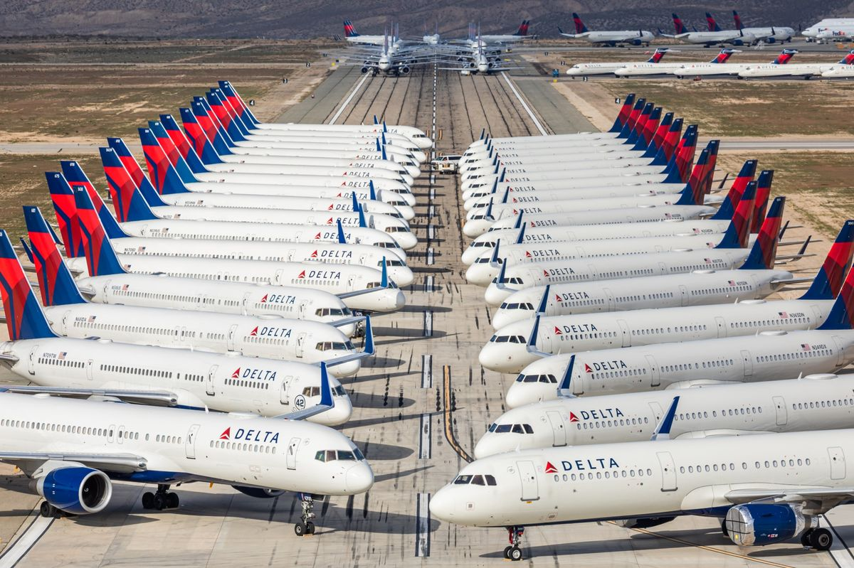
Photo by Bloomberg

Somebody told me that the shops that used to sell textiles in the USA and much of the West, have gone bankrupt. Clothes are now sold on line – through the internet or on phones. This is the way to go, Ugandan entrepreneurs. Stop crying over spilt milk. Look for how to survive in the new atmosphere of tonsemberera (social-distancing). Business People in Uganda need to be very cautious. Let us take Public transporters. If it turns out that People are being infected because of crowding in the Public transport vehicles, that will be the end of that business whether Government lifts restrictions on Public transport or not. People will simply not come. That will be the end of that business. The time of self-deception is over. Let us be serious.

I cannot end this broadcast without talking about our Scientists who have guided us through this crisis and who are also working on the 3 lines of: our own diagnostics; our own vaccines; and our own therapeutics. Stay tuned, there may be pleasant news in the coming months. We have given all the necessary funding.

I thank you.

20th September, 2020 - Nakasero

