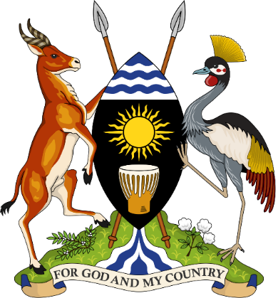
The Republic of Uganda
PROGRESS UPDATE ON THE PRESIDENTIAL FAST TRACK INITIATIVE ON ENDING AIDS AS A PUBLIC HEALTH THREAT IN UGANDA BY 2030 AT THE COMMEMORATION OF THE WORLD AIDS DAY

THEME: END STIGMA, END AIDS END PANDEMICS
KOLOLO CEREMONIAL GROUNDS

December 1, 2021

DR. NELSON MUSOBA
DIRECTOR GENERAL

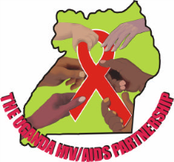 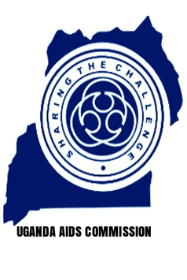 Uganda AIDS Commission
His Excellency President of the Republic of Uganda, Yoweri Kaguta Museveni
Cabinet Ministers,
Heads of Diplomatic Missions,
Honourable Members of Parliament,
Permanent Secretaries,
Representatives of AIDS Development Partners,
Representatives of Religious & Cultural Leaders,
Representatives of Civil Society Organizations,
Representatives of Implementing Partners,
Representatives of People Living with HIV,
Representatives of the Media fraternity,
Uganda AIDS Commissioners, Management and Staff
Ladies and Gentlemen.
Today marks the second time we are marking the World AIDS Day commemoration since the outbreak of the COVID 19 Pandemic in Uganda. It is almost two years since the first case of COVID 19 was detected in Uganda. The pandemic has challenged all of us how we go about our work forcing us to adapt methods for survival.
Now more than ever, we rely on technology to facilitate our would be face to face meetings. COVID 19 has also impacted all of us physically, mentally, socially and financially.
COVID 19 did not spare the National HIV and AIDS Response. However, there is good news, we are emerging stronger; our modelling data working with UNAIDS and the Ministry of Health shows that HIV prevalence has dropped to 5.4% from 6.2% in 2016. There was a 41% decline in HIV testing and 37% decline in referrals for diagnosis treatment due to the pandemic. So we would have performed better.
As a Country we have a masterplan to End AIDS in Uganda called the Presidential Fast Track Initiative (PFTI) which was launched in June 2017 by His Excellency the President. The PFTI is hinged on 5 pillars namely:-
- Engage men in HIV Prevention and close the tap on new infections particularly among adolescent girls and young women;
- Accelerate Implementation of Test and Treat and attainment of the fast track 90-90-90 targets particularly among men and young people; That is 90% of all people who are HIV positive have been identified through HIV testing; 90 % of all who test positive are enrolled on treatment and 90% of all who are on treatment achieve viral suppression. This has been updated to a new target of 95-95-95.
- Consolidate progress on elimination of mother to child transmission of HIV;
- Ensure financial sustainability for the HIV and AIDS response: and
- Ensure institutional effectiveness for a well-coordinated multi-sectoral response.
Your Excellency Uganda has made great progress since this master plan was launched three years ago.
- In terms of engaging men in HIV Prevention and closing the tap on new infections particularly among adolescent girls and young women;
In 2020/21 the following was achieved:
- 182 million condoms were distributed countrywide
- AGYW strategy developed; with age-specific service package; services expanded to 43 from 23 districts
- Overall, 384,665 AGYW served;
  - HIV prevention: 38,701
  - Violence Prevention: 120,736
  - Economic strengthening: 98,353; Vocational skills: 10,000; Enterprise development Assistance: 500
  - School subsidy for vulnerable girls in 40 districts
- Accelerate Implementation of Test and Treat and attainment of the fast track 90-90-90 targets particularly among men and young people. In 2020/21 the following was achieved:
Overall- 94% of PLHIV know theirs status; of these, 98% are on ART; of which 91% are virally suppressed (Overall: 94-98-91)
- Adults: 96-98-92, with females attaining the 2nd and 3rd 95
- Children 0-14 yrs: 63-99-74
- Adolescents 10-19 yrs: 73-80-71
- Consolidate progress on elimination of mother to child transmission of HIV;
In 2020/21 the following was achieved:
96% of HIV positive mothers received ART; with 95% of breast feeding mothers virally suppressed. Among HIV-Exposed Infants, 88% had EID testing; 1.7% sero-converted within 8 weeks and 3% after breastfeeding.
- Ensure financial sustainability for the HIV and AIDS response:
In 2020/21 the following was achieved:
- HIV mainstreaming in MDAs was strengthened. Mainstreaming is where 0.1% of the budget is devoted to HIV Interventions
- 38.8 billion mobilized 2019/20; Budget vote output for 0.1% operationalized
- One Dollar Initiative has so far collected UGX…………. to date
- Ensure institutional effectiveness for a well-coordinated multi-sectoral response.
In 2020/21 the following was achieved:
- NSP 2020/21-2024/25 and M&E framework disseminated
- MDAs have been supported to mainstream HIV and AIDS; establish HIV/AIDS committees, develop their HIV and AIDS strategic plans and work plans
- Coordination structures have been revitalized at district level, within MDAs, and at Sub County level. Now that we have the Parish model, we are looking towards coordination at that level to ensure adequate involvement of leaders and dissemination of messages at the grass roots.
Our fight against HIV and AIDS has been successful largely due to a multi-sectoral approach. As we move toward Ending AIDS as a public Health threat by 2030, we realise the need to focus on key areas that we feel will give us a huge return on investment. These include:
- Harnessing the benefits of our existing partnerships.
Our fight against HIV has been largely supported by Religion and Culture. This is a good practice that has been recognised globally. To date both the Kabaka of Buganda and the Omukama of Tooro are recognised as UNAIDS Good will ambassadors in the fight against HIV and AIDS. These leaders have integrated HIV prevention in their Kingdom Manifestos and subsequently their activities such as the Kabaka Run, Ebyooto and in their speeches to their followers among interventions. It is important to note that UAC not only works with Buganda and Tooro kingdoms but all the recognised cultural institutions in Uganda. On the side of the faith based organisations, we work with all faith based institutions under their umbrella organisation–Inter Religious Council of Uganda (IRCU). As such our HIV prevention messages have reached communities through their structures such as the Mother’s Union, Father’s Union, Home cells, and pre-marital Counselling sessions among others. Both the religious and cultural institutions are doing a good job in prevention of HIV and AIDS, Stigma and Discrimination of PLHIV. However, the capacity of these institutions needs to be improved in order for them to ably disseminate HIV and AIDS prevention messages to the 21st Century believer.
- Focusing on Parenting as a game changer in the fight against HIV and AIDS.
Not a day goes by these days without reports of Teenage Pregnancy, Defilement and Early Marriage in the media. One of the critical spheres of influence that we need to focus on to end early pregnancies and prevent HIV infection is the home. Indeed a lot is being done in terms of providing age appropriate information to the girls and boys on dangers of teenage pregnancy and how to prevent it both in school and out of school which is a step in the right direction. However, the role of parents has not been prioritized as a game changer. Parenting has the power to prevent teenage pregnancy compared to other interventions. This is because parents are the first teachers of culture and religion. Additionally, parents set the tone for individual and societal values, beliefs and behaviour. It is therefore important that parents are equipped with the right information to ably promote those norms and values that promote and protect girls not only from HIV infection but also from Harmful Cultural Practices as well.
- End HIV Stigma and Discrimination
HIV Stigma and Discrimination still remains an issue in the National Response and it impacts on HIV testing, treatment and adherence to treatment. On a positive note, UAC developed the National Policy Guidelines on ending HIV stigma and discrimination which we have embarked on disseminating nationwide. Our request is that that all local government leaders are oriented on the policy so that they can ably disseminate information on HIV stigma and discrimination with communities so that we end Stigma in Uganda.
In conclusion, I thank H E the President of Uganda for the exceptional leadership he has the rendered the HIV and AIDS National Response since HIV was first discovered in Uganda 40 years ago.
I thank the Government of Uganda for prioritising HIV and mainstreaming HIV in their development programmes and budgets.
I thank the First Lady for championing the fight against Mother to Child Transmission of HIV and for consistently reminding us that good parenting is the best tool to fight the negative vices in our Country.
I thank all our esteemed AIDS Development Partners for the financial and technical support towards the response over the years including this trying time as the World battles COVID 19 Pandemic.
I thank the Civil Society Organizations, People living with HIV, the private sector partners, religious leaders, cultural institutions, and the media for keeping HIV on the agenda.
Thank you
Dr Nelson Musoba

